Dependent t-test
A cognitive psychologist is interested in finding the most effective test preparation strategies. She recruits 15 students and has them study for their next quiz by either making flashcards, summarizing, or re-reading lecture notes. The data are below show the number of questions out of 20 each student got correct (each cell corresponds to a different student)
Flashcards | Summarizing | Re-Reading
15 | 14 | 12
16 | 15 | 13
14 | 16 | 14
15 | 15 | 12
16 | 14 | 13

Research question: Is there a significant difference between methods?
- Fill in the table with each group’s mean, within groups sum of squares, (SS_{W}), sum of squares between groups (SS_{B}), Sum of Squares Total (SS_{T}), degrees of freedom
 | Flashcards | Summarizing | Re-Reading
 | 15 | 14 | 12
 | 16 | 15 | 13
 | 14 | 16 | 14
 | 15 | 15 | 12
 | 16 | 14 | 13
Group Mean
SS (within treatments)
df (Within Treatments)
 |  |  |  | M_{G}
 |  |  |  | SS_{w}
 |  |  |  | SS_{T}
 |  |  |  | SS_{B}
 |  |  |  | df_{w}
 |  |  |  | df_{B}

- Using the values from the table, calculate MS_{B} and MS_{W}

- Compute F

- Based on this test, is there a significant difference between study groups? Why or why not?

Formulas
SS Formulas
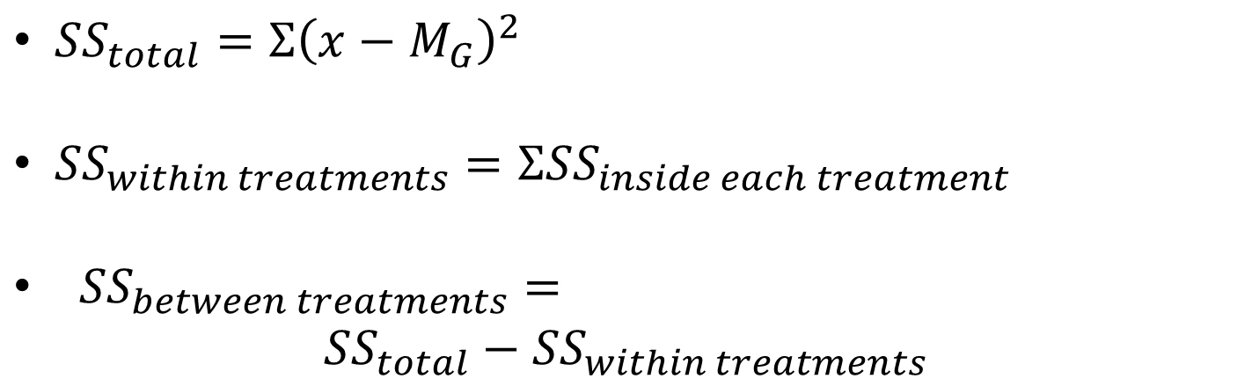

MS Formulas
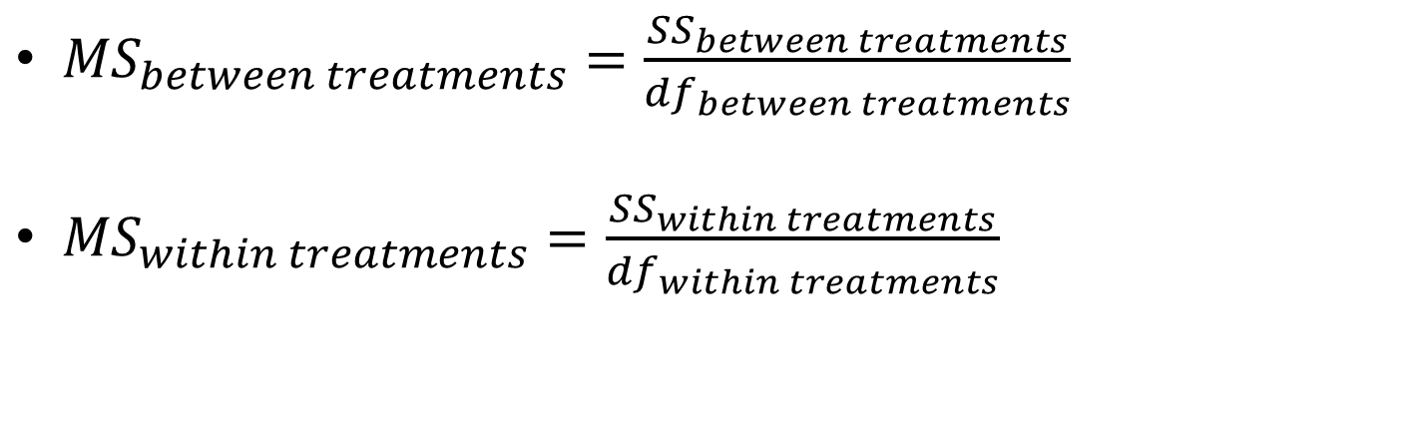

F formula
- MS_{between treatments} / MS_{within treatments}

